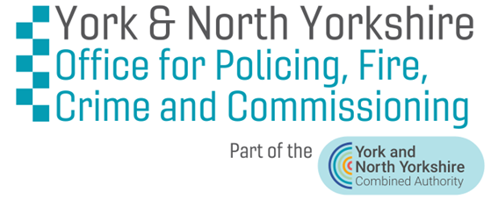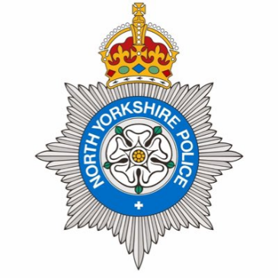

Date as postmark

There is no greater priority than protecting your home, your family, and your community and that's why we are investing in your area with this project to cut crime.

The Office for Policing, Fire, Crime and Commissioning have secured nearly £600,000 from the Home Office, through their Safer Streets Scheme, to invest in the security of your area, Guildhall, York, to make sure that you are safe and feel safe.

We live in such a beautiful county and North Yorkshire is so varied, from its vast rural areas to its busy urban areas. Living in major town such as York means you are well connected to amenities, the local countryside, and the coastline. But with this access and close living, we all know that brings opportunities for criminals that can make this community a target for burglaries.

North Yorkshire Police's local Neighbourhood Policing Team work hard to support and protect residents. But with the increase and demands of this type of crime, it makes it difficult to provide the service that your local policing teams would like and causes your communities to be a target for repeat crime.

**We need to stop that. This money will. But we also need your help.**

The funding is available for the following:

* **To upgrade the security of homes, with the installation of a free Ring Doorbell** – to provide peace of mind.
* **To provide detailed security and crime prevention advice** - which you can find in this pack, to help you protect yourselves.

**SH**

**K**

**IR**

**Get involved, take advantage of this opportunity to protect your home by signing up to receive a free Ring Doorbell, gen 2, and free fitting.**

You can sign up for the doorbell using the below ways:

* Go to **www.ProtectYourHome.org.uk** and register your details on the online form.
* Text **Home** to **07808 654 870** and we will give you a call back.
* Email **help@ProtectYourHome.org.uk** with your name, address, and contact details.
* Call **01423 569 562** and we'll take your details and answer any questions

You can also start to improve the security of your home and property straight away by:

* Placing the property marking stickers enclosed in a prominent place where anyone visiting your home will see them.
* Property marking your valuable items with the marker pen enclosed.
* Reading the crime prevention information provided in this pack and take action where you think necessary.
* Keeping a lookout for **#ProtectYourHome** on social media, and for more crime prevention advice at **www.ProtectYourHome.org.uk**

Please register as soon as possible as you only have until the 13 December 2024 to apply.

We have until the end of March 2025 to complete this work, so act now to help us prevent crime, put off criminals and protect your home.

With best wishes,

David Skaith – York and North Yorkshire Mayor

Jo Coles – York and North Yorkshire Deputy Mayor for Policing, Fire and Crime

The York and North Yorkshire Office for Policing, Fire, Crime and Commissioning

The York and North Yorkshire Office for Police, Fire, Crime and Commissioning  
Harrogate Police Station, Beckwith Head Rd, Harrogate, HG3 1FR  
[www.northyorkshire-pfcc.gov.uk](http://www.northyorkshire-pfcc.gov.uk)  
01423 569 562