

**LOCAL PENSION BOARD**

## **Report of the Head of Finance and S151 Officer to the Chief Constable**

**26 July 2024**

**Pension Update**

**Status: To note**

**Purpose of the Report**

* 1. The purpose of the report is to provide Members with scheme information, together with updates on current issues and training.

**Recommendations**

### 2.1 That the North Yorkshire Local Pension Board *notes* this NYFRS pension update.

**Scheme Membership Information**

3.1 The active membership of the firefighters’ pension schemes is taken from pay data as at 31 March 2024 for Tax Year 2023/24 and is detailed in the table below. All firefighters are in the 2015 scheme now where old schemes were closed to accrue at 31 March 2022.

|  |  |
| --- | --- |
| Active Membership Total | 607 |
| Wholetime | 291 |
| On-call | 316 |
| Leavers | 49 (not included in the total number) |
| Opted Out | 19 |

3.2 The firefighters’ pension schemes are unfunded schemes where benefits are paid out of contributions and Government top-up grants. For information, HM Treasury is looking to increase all contributions rates by 0.2% to align the average rate to the target rate which was lower than expected in the 2020 valuation results. For a member earning £35,000 with a 20% marginal tax rate, this would equate to an additional £4 to £5 per month reduction in take-home pay. Government Actuary’s Department is also going to review pension contribution band thresholds. Further information will be available in due course.

**Pension Remedy – Sargeant**

3.1 In 2015, the government introduced new laws which resulted in a new pension scheme for firefighters - the Firefighters' Pension Scheme 2015 (FPS 2015). These laws included protection for some members of the existing schemes (FPS 1992 and FPS 2006) who didn't join FPS 2015 either straight away or at all, depending on their age. Following a legal challenge known as the Sargeant judgement, the courts determined that the protections given to members were age discriminatory.

3.2 On 15 July 2019, the government accepted the court’s decision and confirmed that they would engage with the Employment Tribunal to agree how to fix (remedy) the discrimination. The government confirmed the remedy would apply across all public sector schemes and therefore is known as the ‘Sargeant Remedy’ for firefighters but also as the ‘McCloud remedy’ across the public sector and the ‘Age discrimination Remedy’.

3.3 The Police and Firefighters Pension Scheme regulations 2022 came into force on 1 April 2022. The firefighters Pension Scheme (Remediable Service) regulations 2023 came into force on 1 October 2023. To allow for tax implications of remedy to be rectified two set of regulations have been published: [the Public Service Pension Schemes (Rectification of Unlawful Discrimination) (Tax) Regulations 2023 (legislation.gov.uk)](https://www.legislation.gov.uk/uksi/2023/113/contents/made) Tax no.1 and no. 2.

**Pension Remedy Period**

3.4 'The Remedy period’ is the period from 1 April 2015 to 31 March 2022.

3.5 The changes to remove future discrimination were brought into being on 1 April 2022 which means all future service benefit for all members is accrued within the FPS 2015 scheme from that date. Benefits already accrued in either the FPS 1992 or FPS 2006 are fully protected under those schemes.

3.6 The changes to remove past discrimination came into force on 1 October 2023. Members who moved into FPS 2015 within the remedy period will have their benefits converted to their legacy final salary scheme (either FPS 1992 or FPS 2006) for the whole of their service in the remedy period.

3.7 The complications arise as there are many different scenarios that result in the changes to remove past and future discriminations for active, deferred and pension members. In order to inform individuals all pension fund members will receive a remedial service statement (RSS).

**Statutory Requirements and Timetable for Remedial Service Statements (RSS)**

4.1 Through the Commissioners’ Corporate Governance Framework, the Chief Fire Officer holds delegated responsibility in relation to the Firefighters’ Pension Scheme Discretions, on behalf of the Scheme Manager, who is the York and North Yorkshire Combined Authority Deputy Mayor. Responsibility for Statutory deadlines is met by the NYFRS Payroll and Pension team who work closely with the Pension Scheme Administrator (West Yorkshire Pension Fund) to provide RSS. If our statutory deadlines are not met, the pension regulator can impose a charge.

4.2 It is important to note that the regulations allow 18 months for pension administrators to complete the remedy exercise (i.e., until March 2025). **Pensioner** members who retired before 30 September 2023 and have service within the remedy period, will be provided with an RSS as soon as reasonably practicable from 1 October 2023. This is known as Immediate Choice (IC) or IC-RSS.

4.3 There were several policy issues on the application of tax and interest. There are on-going technical issues with regards to calculating the tax charges due on remediable lump sums which is causing a delay in issuing Immediate Choice Remediable Service Statements (IC-RSS). The delays being experienced are solely due to a lack of clarity, from both HM Revenue & Customs (HMRC) and HM Treasury (HMT), about some specific technical issues which affect some members.

4.4 Tax issue affects all members who fall into the red category i.e. unprotected and *taper protected legacy FPS 1992 members who elected for maximum lump sum (and paid an unauthorised tax charge) when they originally retired *who at point of retirement had tapered into FPS 2015. Members who fall into the amber category as protected and *taper protected legacy FPS 1992 members who elected for maximum lump sum (and paid an unauthorised tax charge) when they originally retired will only be affected by the issue should they elect for reformed benefits i.e. FPS 2015 benefits, on receipt of their IC-RSS *who at point of retirement had not tapered into FPS 2015. Green category pensioners will not be impacted by the ongoing tax issue relating to the taxation of lump sums. Amber category pensioners will be processed if the tax issue does not affect some of these members so will be carefully considered.

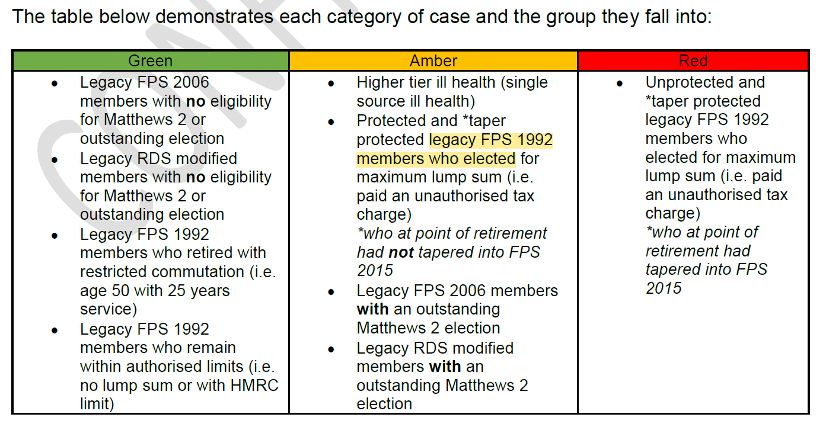

4.4. Administrators will be prioritising certain categories of pensioner members, based upon the level of impact of remedy to their benefits. WYPF have now started production of the IC-RSS for those members in the green category. The indicative timetable for sending out RSS to **pensioner** members is:

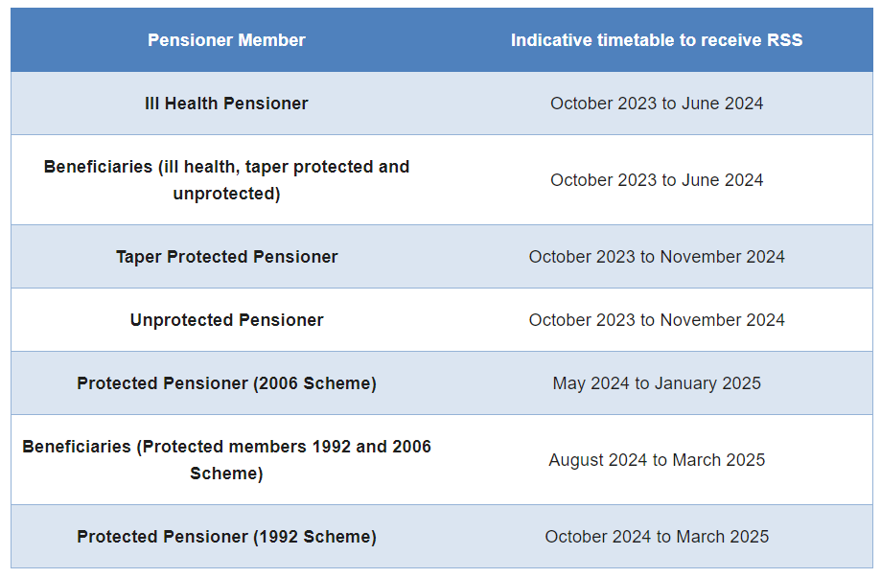

The definition of the different types of Pensioner Members (detailed in the table above) and different scenarios is shown at Appendix A.

4.4 One scenario that has recently come to light is from HMRC in its published Pension Schemes Newsletter 156 which sets out the tax treatment of interest paid as a result of remedy. This has stalled the IC rollout process due to the initial 8% interest that was promised to members will now result in tax implications for some of them. The issue identified only affects members who have received an unauthorised lump sum, these are members with legacy FPS 1992 membership who when they retired received an unauthorised lump sum and paid a tax charge. Consequently, this new development has had an impact on the RSS timetable, so the deadlines have been pushed back where the decision from HMT is expected after Parliament summer recess; a further update will be provided in due course.

4.5 The indicative timetable for sending out RSS to **Active** and **Deferred** members:

* + - * **Annual Benefit Statement / Remedial Service Statement combined by 31 August 2024.**

ABS/RSS 2024 will not be available for those members who are in scope for Sargeant remedy by 31 August 2024. ABS/RSS 2024 must show ‘rolled back’ position of the benefits members built up in their legacy schemes, which do unfortunately cause some complexities as additional data and software is required to produce these calculations. WYPF is working with its software providers, and it is estimated ABSs will be available at the earliest in December 2024. Out of scope statement will be issued by 31 August 2024 and this amounts to 52% of the total membership.

The **ABS/RSS will provide:**

* + - * + current value of both their legacy final salary benefits
        + reformed FPS 2015 benefits for the remedy period
        + projected benefits to normal pension age for active members.

4.6 Where members have changes in ‘pension input amounts’, which for example could occur if member benefits exceed the annual allowance, then a Pension Saving Statement (PSS) is usually issued. PSS inform members what their total annual accrual into their pension is, so they can work out their tax liability and how to pay it, either direct to HMRC or deferred to retirement from their pension pot via the ‘Scheme Pays’ option. For members impacted by the remedy, the deadline to receive a revised PSS for the affected tax years in the remedy period has been extended to 6 October 2024. Scheme Pays Debit members will need to use HMRC calculator which is down at the moment. This affects the 1992 members who cannot use the calculator and will need to contact HMRC direct.

4.7 The deadline for producing Remedy Pension Saving Statements up to the 2022/23 year and statements for 2023/24 is 6 October 2024. Because production of the ABS-RSS is delayed WYPF will not be able to use this process to produce Pension Savings Statements. Pension administrators are manually working through cases where the member currently has a Scheme Pays debit and will then move on to those who breached the Annual Allowance threshold in 2022/23 and continue to work backwards to the 2015/16 tax year. Now pension administrators are working towards production of the majority of statements by the deadline. However, there could be a possibility of another breach of law of not meeting the statutory deadline of 6 October 2024.

4.8 NYFRS will be informing the Pension Regulator with regards to the above-mentioned breaches of law if required, WYPF will also report the breach to the regulator. Further information will be communicated to members in due course.

4.9 Members who started their service on or after 1 April 2015 will not be affected by WYPF software issues and will receive their ABS only (no RSS) by 31 August 2024.

**Current NYFRS Pension Remedy position**

5.1 **Resources** - The following data shows the information that has been and continues to be processed by the Payroll & Pension Team who are working hard to meet the required deadlines. The lack of resources have been included in the risk registers.

5.2 **Pension Regulations and Contingent Decisions** - The complexity of the pension remedy regulations should not be underestimated with the Local Government Association (LGA) Pension Advisors holding meetings every 2 weeks to update on continual changes. An example of a decision the Scheme Manager has had to make is with regards to a Contingent Decision which is provided in Appendix A “Definitions – Different Types of pensioner members, scenarios and examples”. This case is being finalised after many weeks of discussion between the Scheme Manager (Chief Fire Officer), the FBU and People Services. It is worthy of note Contingent Decisions in relation of the 1992 opt outs are on hold following the change in the Home Office’s position. CD GAD calculator is not available to calculate the tax and interest. If a contingent decisions member is due to retire, then the case will be processed manually by the administrators.

5.3 **Data processing to required deadlines to meet statutory requirements:**

30 Sept 2023 **Completed** Remedy Data (in line with guidance 2021) cleansed / sent to

WYPF

01 Mar 2023 **Completed** Finalised Data sent to WYPF following queries

2 May 2024 **Completed** Contributions data for GAD (actuary) calculator request from WYPF for RSS

9 July 2024 **Ongoing** WYPF has raised further queries regarding the financial data which are being worked through.

17 July 2024 **Ongoing** WYPF advised to re-run GAD data through GAD calculator to reflect NS&I rates update. Awaiting WYPF’s confirmation regarding the dates the interest and tax need calculating to.

5.4 **Pension Remedy data processed:**

**576** (**100%**) GAD data completed at 2 May 2024 and sent to Pension Administrator (WYPF). Further work is needed to reflect the NS&I rates’ change in June. Financial information needs further work pending data queries from WYPF.

**2 (100%)** Number of Added Pension Refunds made by 31 Mar 2024

**1 (100%)** Ill health reassessment to be processed by 30 June 2024

**2 (100%)** Contingent Decision made within the 2-month deadline since receipt.

**Retained Fire Fighters Remedy - Matthews**

6.1 A legal settlement under the Part-Time Workers (Prevention of Less Favourable Treatment) Regulations 2000 allowed certain **retained firefighters** with service between 1 July 2000 and 5 April 2006 to become members of the Firefighters Pension Scheme.

6.2 These eligible firefighters were asked whether they wanted to join this scheme in an options exercise (first options exercise) which took place in 2014-2015. Elections to join had to be received by 30 September 2015. This was the ‘first options exercise’.

6.3 More recently, this judgment was challenged at the European Court of Justice. The Court ruled that service going back to the start of employment *could* be taken into account. The government accepted that the same principles apply to certain retained firefighters, whether they have made a legal claim or not. A memorandum of understanding was agreed by the government, representative bodies, and Fire and Rescue Authorities (FRAs) on 9 March 2022.

6.4 A second options exercise is now taking place to allow eligible retained firefighters to buy pension service as a special member of the FPS 2006, backdated to the start date of their employment. The exercise will run for a maximum period of 18 months (October 2023 to March 2025) after it begins.

6.5 NYFRS is currently reviewing all the data from the first options exercise and has identified:

* **609 retained fire fighters** identified in scope for the second options exercise and have received notification letters by 31 December 2023, then chased again in May-June 2024 when tracing agency ITM located lost contact members.
  + **294** retained firefighters responded; **282** members have not returned the forms; **9** firefighters expressed no interest; **24** deceased cases are on hold pending further clarity from the LGA how to proceed with these cases.
* By **30 June 2024 the data has been collated** to start the calculations process using

GAD calculator for **294** expression of interest forms received.

**Communication**

6.1 Communication to all pensioners, deferred and active members is key and further information is put out internally by way of weekly bulletins as well as placed on the website and individual updates provided where appropriate e.g., ill health retirements and Matthews’ exercise. NYFRS website updated with the latest pension update available to members

6.2 Communication with Trade Unions is ongoing where they can attend pension remedy update meetings and the Local Pension Board.

6.3 The LGA Pension Advisors have recently stressed the importance of keeping all members updated as to the current pension remedy and the ever-changing situation to provide ongoing support, which the Service will continue to do.

6.4 Communication for on-call firefighters - in order to provide a remedy to those on-call firefighters affected by the O’Brien judgment (the part-time civil judges’ court case), a second options exercise will take place to provide access to the 2006 Scheme as special members from the start date of their service, subject to the payment of appropriate contributions. Letters requesting expressions of interest have been sent to individuals identified as being in scope for the exercise. Matthews expression of interest forms and guides issued in December and chased again in May-June 2024 on the back of tracing agency work done to locate lost contact members. The tracing exercise also obtain 57 lost deferred members’ addresses for WYPF.

6.5 Communication regarding unauthorised cases - ahead of the legislative changes which are needed for existing unauthorised cases, several cases can be progressed and have their IC-RSS issued. The case types can be split into three ‘traffic light’ groups:

**Green** – Suggests that a case **can** be processed as there is no indication that a member has or could enter the unauthorised space.

**Amber** – Suggests that a case **could** be processed but caution is needed as either LGA have some outstanding questions for HMRC or as they are a protected member, they are unlikely to elect for alternative benefits.

**Red** – Suggests that a case **cannot** be processed until we have clarity on the legislative position for the treatment of unauthorised cases.

* 12 red category pensioners were written to in June 2024 with IC-RSS rollout update and tax implications explained.
* Further 138 pensioners (green and amber categories) received their remedy update letters during the first week of July at the Chief’s request to contact these members individually.
* ABS-RSS delay letters will be circulated by WYPF who will contact the affected members.

**Author: Nellie Murray**

**Senior Pension Advisor**

**Appendix A**

**Definitions – Different Types of pensioner members, scenarios, and examples**

**Ill Health** retired on ill health grounds and is given instance access to retirement benefits

**Beneficiary** death in service pensioner or deceased pensioner

**Taper protected** transitioned over to the 2015 FPS at a given time dependent on age and service

**Unprotected**  members who joined FPS 2015 on 1 April 2015 with no protections applied

**Protected** members who stayed in their legacy scheme up until 31 March 2022

**Contingent** Under the Firefighters’ Pensions (Remediable Service) Regulations 2023,

**Decision** only service within the remediable period 1 April 2015 to 31 March 2022 can be considered for reinstatement to the relevant legacy scheme via a contingent decision. Opted-Out Service that occurs prior to 1 April 2015 or after 31 March 2022 cannot be considered as part of a Contingent Decision and any such periods are subject to the regulations in force at that time. Following the recent update received from the Home Office the only legacy scheme membership available for the remedy period is FPS 2006. Official statement will be released in due course.